**NAME: BIKORIMANA Felix**

**REG NO: 221003637**

**YEAR 2 CSE**

**ACADEMIC YEAR 2021-2022**

**WEB TECHNOLOGY**

**Table of Contents**

**LIST OF FIGURES 2**

**1. Introduction 3**

**1.1 Project Summary 3**

**1.2 Problem statement 3**

**1.3 Objectives 3**

**1.4 Project Rationale 3**

**2. Methodologies and Methods 3**

**2.1 Data collection methodology 3**

**2.2 Tools to be used 3**

**2.2.1 Hardware tools 3**

**2.2.2 Software tools 3**

**3. System Analysis and Design 3**

**3.1 Requirement Specifications 3**

**3.1.1 Functional requirements 3**

**3.1.2 Data Requirements 3**

**3.1.3 User Requirements 3**

**3.1.4 Security Requirements 3**

**3.1.5 Non-functional Requirements 3**

**3.2 System Design 4**

**3.2.1 System overall architecture 4**

**3.2.2 System information flow 4**

**4. System Implementation 4**

**4.1 Landing page 4**

**4.2 Login page 5**

**4.3 And so on, at least 5 pages of you 6**

**5. Conclusion 7**

**6. Recommendation 7**

**7. Appendix 7**

# **LIST OF FIGURES**

**Figure 1: Overall structure 3**

**Figure 2: Project landing page 4**

**Figure 3: Login page 4**

**Figure 4: List of users 5**

**Figure 5: User details 5**

**Figure 6: Edit option 6**

# Introduction

## Project Summary

**HOSPITAL MANAGEMENT**

Hospital management service Is inline platform that will help patient on hospital to get service fast and easy. where the patience will fast and go to this platform to put his or her record information about him or her, if she has other chronic disease so that to avoid wasting time on hospital waiting doctor other to get consultation this will be easy and fast because you will receive appointment of doctor this will help to patient to reserve time when reach on hospital.

Avoiding use of paper on hospital and enhance better service on hospital this platform will work on google typing [www.hospitalmanagment.gov](http://www.hospitalmanagment.gov) and patient fulfill requirement then receive unique number

This platform is for platform users (service provider, service seeker) which help to connect those people

We will create admin who control the security of our platform

## Problem statement

**PROBLEM MY PLATFORM ARE GOING SOLVING**

**CUSTOMERCARE OF HOSPITAL**

Some hospital receive more patient then began to produce bad customer through the many condition like nepotism system of hospital like uncontrolled worker

INTERFERENCE OF PATIENT

When patient meet with hospital at high it causes interference of service then start to blame hospital produce low customer care to patient

WASTING TIME TO HOSPITAL

Sometime patient waiting doctor due to a lot of job missing doctor then began to blame hospital

Mu platform is going to save time of patient and doctor

## Objectives

To solve the wasting time of patient

To connect doctor with patient easy

Help patient to get consultation in easy way

## Project Rationale

* It will help patient get appointment without spending time to hospital
* It will help doctor to access the information of patient then plan their appointment
* It will help service of hospital because many people will be registered before coming
* Data will be recorded in easy way then analyze those data easy

# Methodologies and Methods

## Data collection methodology

* Secondary data research
* Visited site of hospital from ma childhood
* Analyzed customer care of many hospitals

## Tools to be used

### Hardware tools

* Computer for controlling this data
* mouse

### Software tools

* Software apps
* Database
* Programming language

# System Analysis and Design

## Requirement Specifications

### Functional requirements

* Home function
* Service function
* Login form function
* Registration form function

### Data Requirements

ENTRY DIAGRAM RELATIONSHIP TABLE

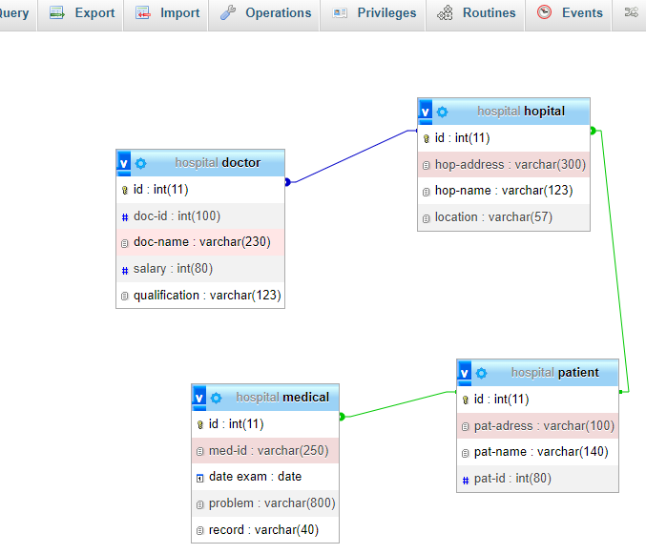

### User Requirements

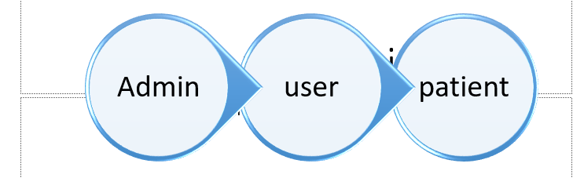

### Security Requirements









### Non-functional Requirements

* What is the system performance?
* What is the system reliability?
* What is the system accessibility?

## System Design

### System overall architecture

* E.g.: overall system flow.









*Figure 1: Overall structure*

### System information flow

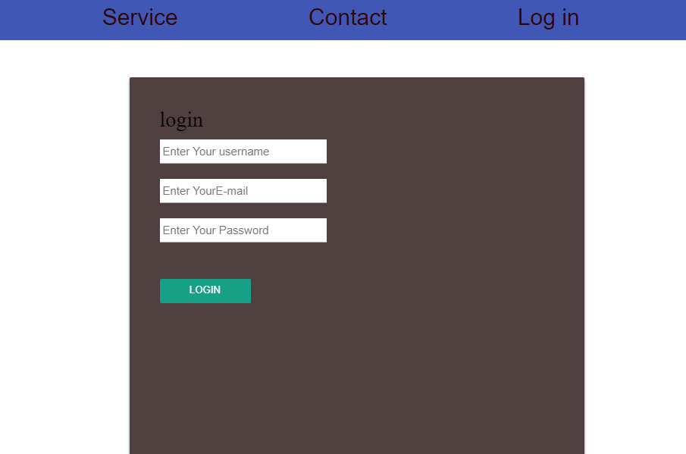

# System Implementation

* Some screenshots.

## Landing page

This picture detail the landing page of the proposed project. From this page you can see the books with its details. You can be given the option of searching and also seeing more details. When you click on more details button, you will be given the option to read the book or download it.

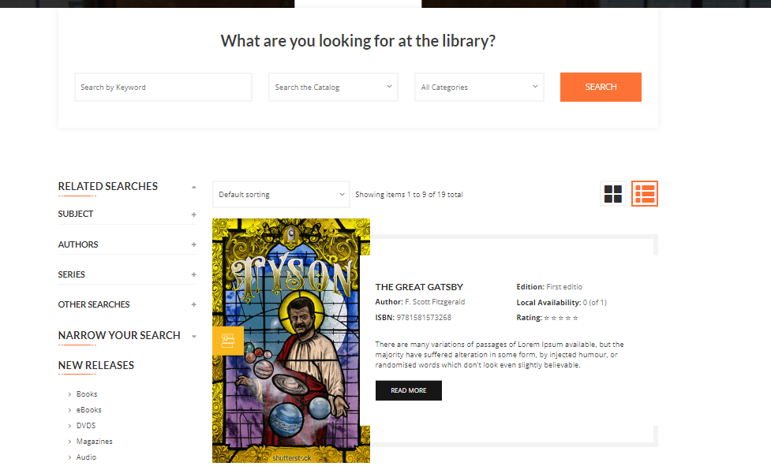

*Figure 2: Project landing page*

## Login page

*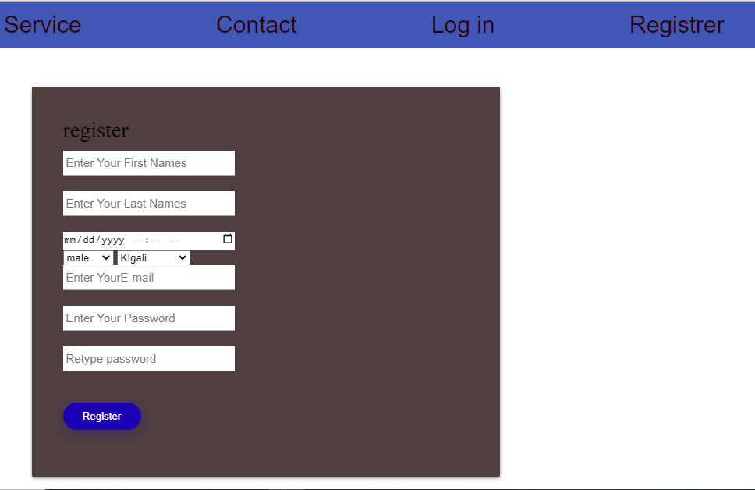Figure 3: Login page 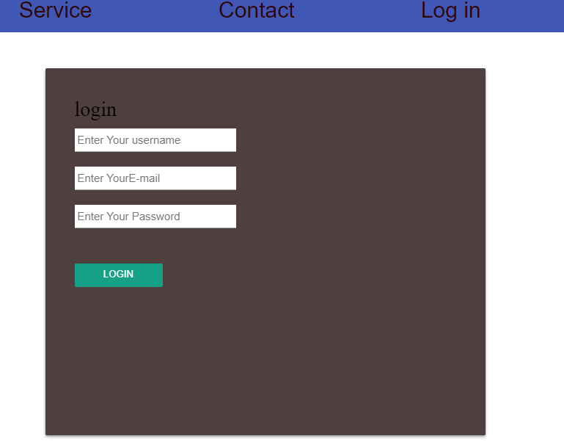*

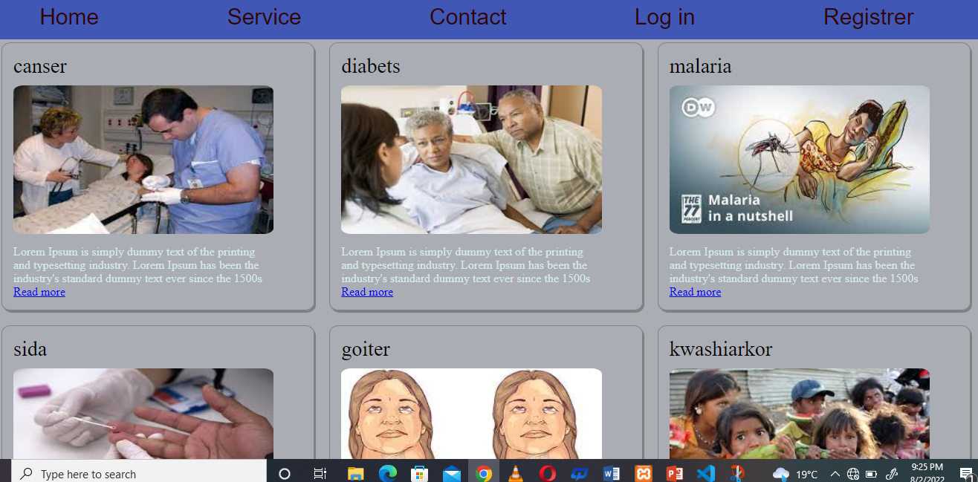 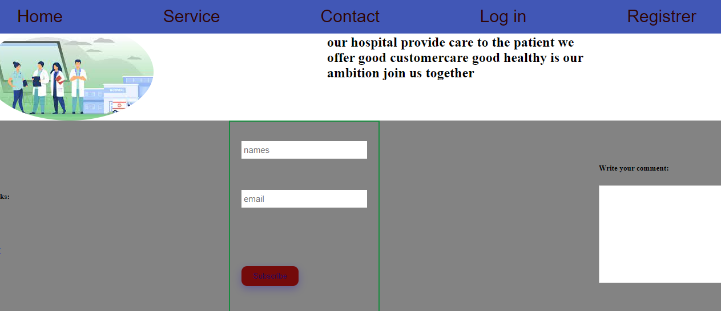

# Conclusion

The Hospital Management system aids in the centralization and automation of hospital task management. The software handles and secures patients’ information, prescriptions, diagnosis, and other hospital and patient-related data and digitally records them in its database.

And that ends our discussion about Hospital Management System Project Proposal, Modules, Documentation PDF, and PPT. You may check the complete illustration of Diagrams, Source Codes, and Documentation by clicking the titles of each explanation.

Now that you have known the parts and definition of creating a Hospital Management System Project Proposal, you can also start creating your own Modules and PDF Documentation

# Recommendation

For me as student it was hard task it’s my first experience

Problem was time short of time push me to skip JavaScript because I haven’t enough knowledge do it was difficult to me but am going to keep moving forward

To our department we need more time and more revision

About beneficiary it is good idea or project it require investment to be developed

# Appendix

* https://github.com/felixaveiro/webtechnologyproject